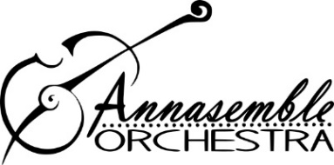
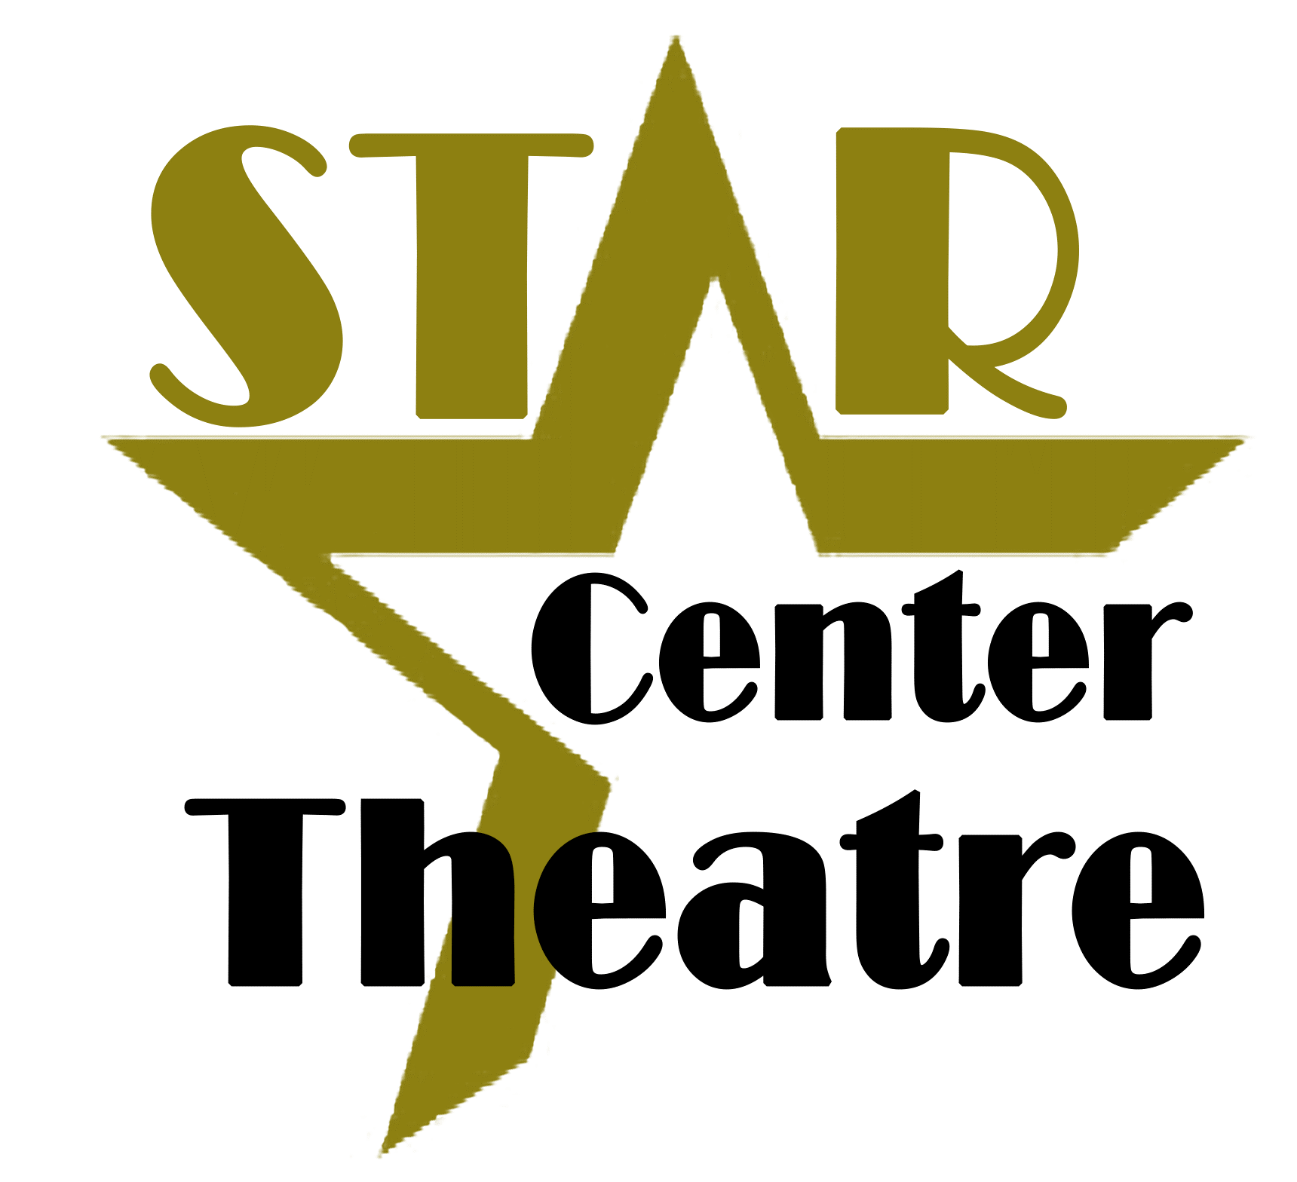

Annasemble Community Orchestra of Gainesville, Inc.
www.annemiekecoron.com/annasemble.html
annemiekecoron@gmail.com

Come Play - with an orchestra - For A Day!
Bring an (acoustic) instrument and join Annasemble Community Orchestra
All Ages Invited – Kids bring an Adult!

Sunday, March 24, 2019
Workshop: 2:00 PM – 3:00 PM

3:30 PM:
Play along at the Concert Performance by
The Star Children’s Theatre and the Annasemble
At the
Thelma Boltin Center
516 NE 2nd Ave, Gainesville
PARTICIPANT INFORMATION FORM cut here
Please return the information before March 1, 2019 - Directions/Sheet music will be provided prior to the event
Name of Participant:_________________________________ Age/Age group:________ email ___________________________
Instrument:__________________Level – please describe (have you received lessons in this instrument – how long
– give any possible description that may help us give you an appropriate part/direction)
____________________________________________________________________________________________________________
____________________________________________________________________________________________________________
____________________________________________________________________________________________________________
Signature:___________________________ (under 18, please signed by parent/guardian)
Name of Participant:_________________________________ Age/Age group:________ email ___________________________
Instrument:__________________Level – please describe (have you received lessons in this instrument – how long
– give any possible description that may help us give you an appropriate part/direction)
____________________________________________________________________________________________________________
____________________________________________________________________________________________________________
____________________________________________________________________________________________________________
Signature:___________________________ (under 18, please signed by parent/guardian)
Name of Participant:_________________________________ Age/Age group:________ email ___________________________
Instrument:__________________Level – please describe (have you received lessons in this instrument – how long
– give any possible description that may help us give you an appropriate part/direction)
____________________________________________________________________________________________________________
____________________________________________________________________________________________________________
____________________________________________________________________________________________________________
Signature:___________________________ (under 18, please signed by parent/guardian)

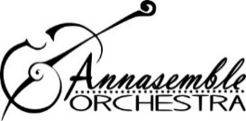
Dear Musician,
We invite you to join our workshop/play-along event. We invite all that play an acoustic (not electric) instrument. At 2 PM we will start practice and exploring what it is like to play in an orchestra. All levels are welcome. All ages are welcome, so please bring your siblings and/or parents- grand-parents. We will practice the Canon in D, by Pachelbel. At 3:30 PM the concert performance will start in co-production with the Star Children’s Theatre. At this concert we invite you to participate by playing along with the Pachelbel Canon. The workshop and concert are a free event.
In order for this event to be successful, it is helpful to gather information about your (and your family’s) level of playing. Please fill out the form and return to your teacher or have your parent email me at annemiekecoron@gmail.com. I will then send out instructions and sheet-music to you. I look forward to meeting you and to making music together!
See you there!

Annemieke Pronker-Coron,
Music Director, Annasemble Community Orchestra

Annasemble is an inclusive, non-competitive yet challenging orchestra for high school and adult members and provides the community with music enrichment, education and performances.

